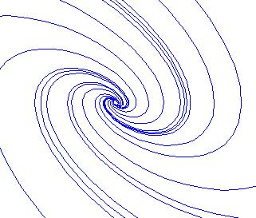
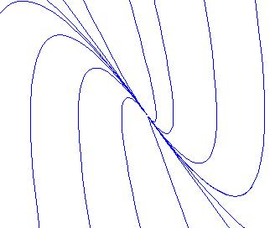
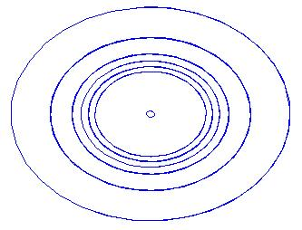
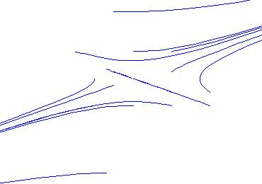
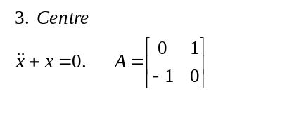
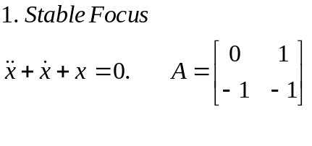
eig(A)

-0.5000 + 0.8660i
-0.5000 - 0.8660i
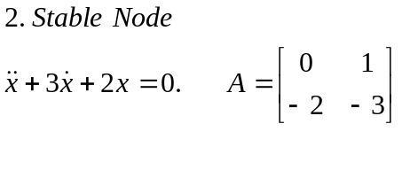
eig(A)
-1
-2

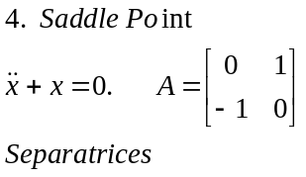
eig(A)
1,-1

TYPES OF EQUILIBRIUM POINTS
eig(A)
0 + 1.0000i
0 - 1.0000i
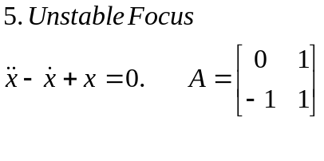
eig(A)

0.5000 + 0.8660i
0.5000 - 0.8660i
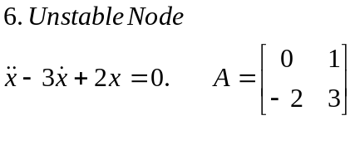
eig(A)
-1
-2

function c = node(t,x)
c=[x(2);-2*x(1)-3*x(2)];

Name the above file as node.m The code below can be saved as an m file, save the file in the same directory where node.m is saved. You can also write the code below in the command window

xinit = [[(0:0.5:3) (0:0.5:3) -(0:0.5:3) -(0:0.5:3)]' [(0:0.5:3) -(0:0.5:3) (0:0.5:3) -(0:0.5:3)]' ];

figure(1)
plot( xinit(:,1), xinit(:,2), 'rx' ); hold on

for i = 1:28
[ t, x ] = ode45( 'node', [ 0 20 ], xinit(i,:));

figure(2)

plot( x(:,1), x(:,2), '-' );
hold on
end

plot(t,x)
size(x)

